composer create-project laravel/laravel ecommerce
composer require laravel/jetstream
php artisan jetstream:install livewire –dark
eliminar esto de composer.json: \"php artisan pail --timeout=0\"

importación de varios modelos
php artisan make:model Family -m
php artisan make:model Category -m
php artisan make:model Subcategory -m
php artisan make:model Product -m
php artisan make:model Variant -m
php artisan make:model Option -m
php artisan make:model Feature -m
php artisan make:migration create_option_product_table
php artisan make:migration create_feature_variant_table

php artisan make:seeder FamilySeeder

php artisan db:seed

php artisan make:component AdminLayout
alt + shift +f

npm run build
npm install flowbite

JETSTREAM HABILITAR LO DE LAS INICIALES
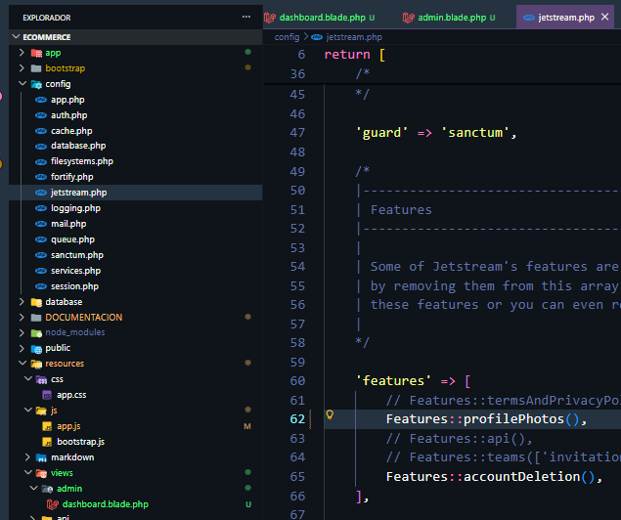

Puse un dropdown en el navigation.blade.php

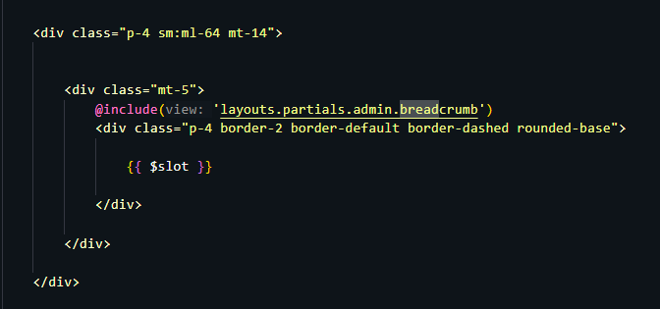
Mandarlo a llamar el bradcrumb a admin.blade.php

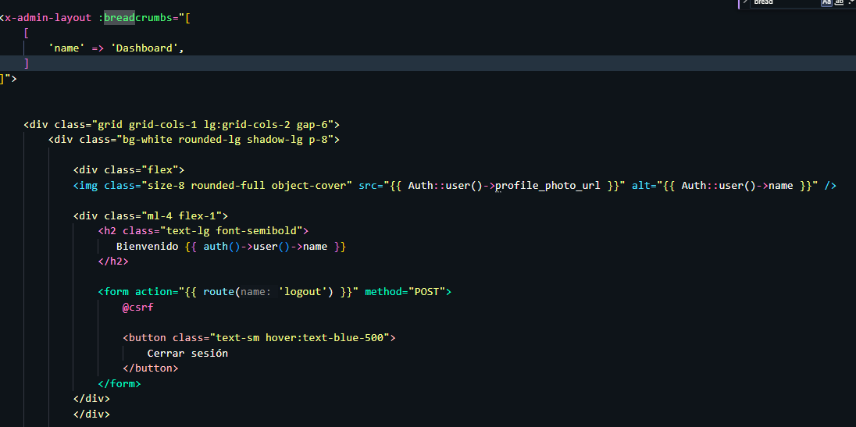
Definir array de breadcrumb en el dashboard.blade

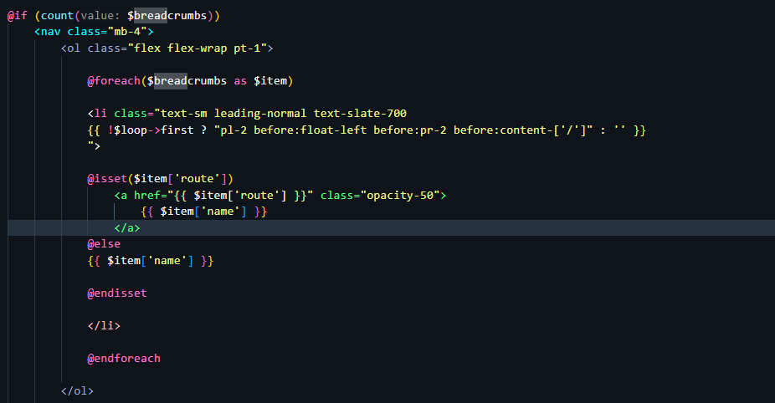
Luego definir los elementos en el breadcrumb

